|  |  |
| --- | --- |
| Project name | Smart waste management system for metropolitan cities |
| Team ID | PN82022TMID26658 |

1. IBM CLOUD LOGIN PAGE:

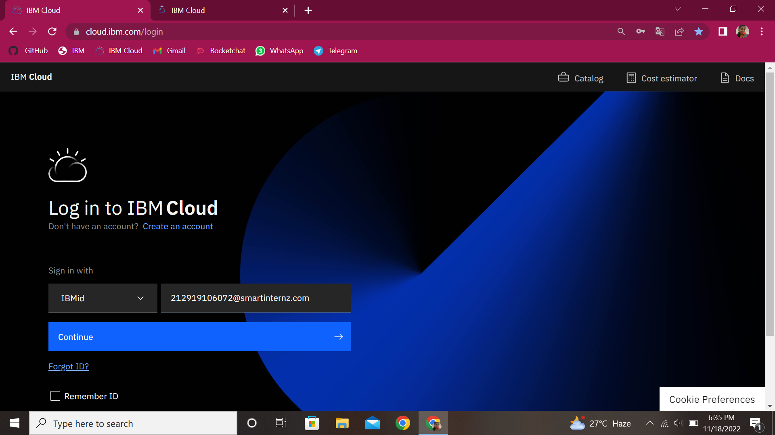

2.IBM CLOUD DASHBOARD

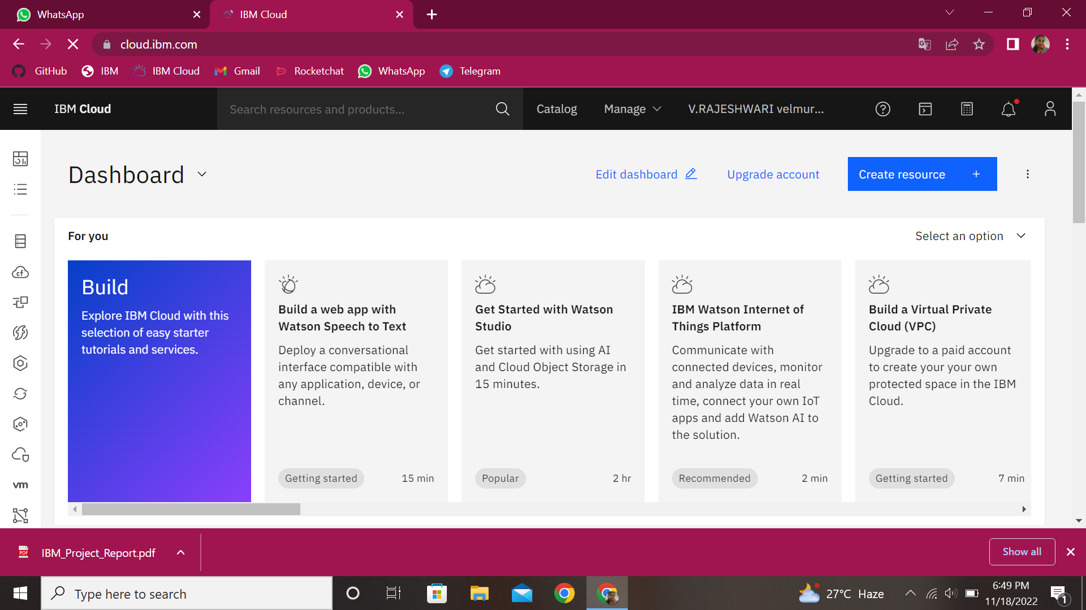

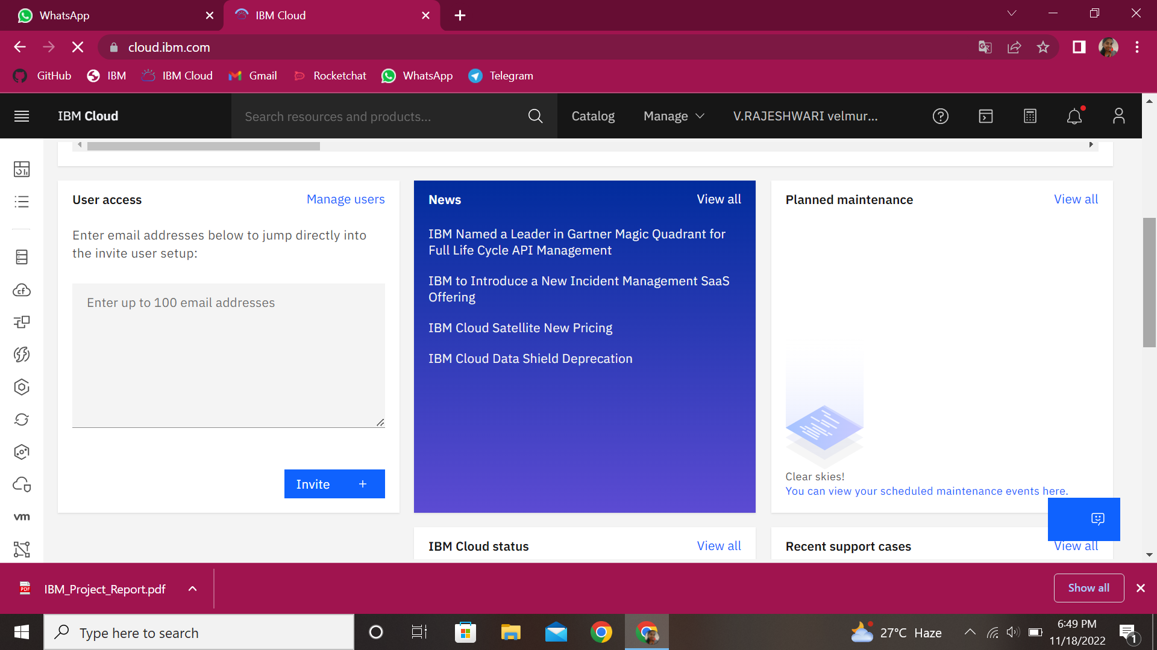

IBM CLOUD SUCCESSFULLY REGISTERED..